About Department
The Department of Economics was established in 1979 with a vision to promote academic excellence and economic awareness among students. The department focuses on teaching Economics in a simple, practical, and research-oriented manner so that students can understand economic issues at local, national, and global levels. It provides opportunities for skill development through academic activities, seminars, workshops, and field-based learning. The department also supports students in building careers in higher education, banking, finance, corporate sectors, entrepreneurship, and public services.
Objectives
- To strengthen students’ understanding of economic theories, principles, and current economic issues.
- To develop analytical thinking and decision-making skills for solving economic and social problems.
- To encourage practical learning through on-job training, projects, field visits, and research in banking, finance, industry, and public policy.
- To prepare students for higher education, competitive examinations, and professional careers in various sectors.
- To promote financial awareness, entrepreneurship, and sustainable economic development among students.
Details of faculty members
Sr. No | Name of the Faculty | Designation | Qualification | Photo
1 | Mr. Sanjay Rama Dayare | Assistant Professor & Head of the Department | M. A., NET, SET, B. Ed. | 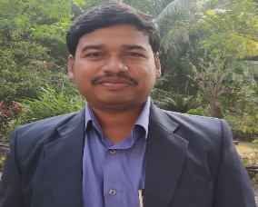
2 | Dr. Pratik Sasane | Assistant Professor | M. A., Ph. D. | 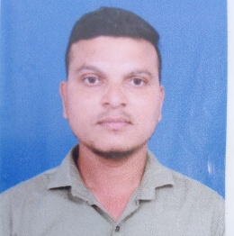
3 | Mr. Kamalakar M. Hirawa | Assistant Professor | M. A., SET. | 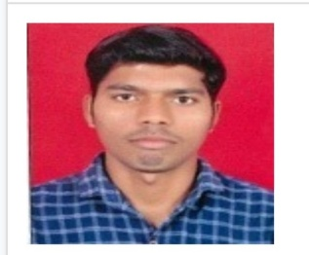
4 | Miss. Rutuja C. Hojage | Assistant Professor | M. A., SET.
5 | Miss. Riya Jackson | Assistant Professor | M. A., B. Ed. | 

The Department honours its former Heads Late Dr. B.D. Bansode, Late Prof. R.P.Kothawale(author fo Maharashtra’s First Economics SET guidance book) and Dr. V.S. Kulkarni whose legacy continues to inspire.
Prof. Sanjay Dayare worked as a Research Assistant with Prof. Dr. Neeraj Hatekar and Prof. Dr. Satyanarayan Kothe of Mumbai School of Economics and Public Policy, University of Mumbai, Mumbai for the Panvel Municipal Corporation Environmental Reports (2018–2021). He also completed a BCUD-funded project on the Khopoli Municipal Council Environmental Report. He has published research papers in international journals, presented papers at conferences, and contributed to the First-Year Economics textbook of the University of Mumbai.
Innovative Teaching-Learning Practices
The department uses both traditional and modern teaching methods to improve student learning. Classroom teaching is supported by presentations, group discussions, seminars, case studies, project work, and field visits. Students are encouraged to participate in research activities, data analysis, and practical assignments. Share market training and financial literacy sessions help students understand real economic situations beyond textbooks.
Student Achievements and Alumni Success
The Department of Economics takes pride in the achievements of its students and alumni. Mr. Rupesh Shid successfully qualified the NET-JRF examination and is currently pursuing his Ph.D. at Indian Institute of Technology Bombay. Many students have also performed well in university examinations and competitive exams. Their success reflects the strong academic foundation and practical learning provided by the department.
Timetable (go through seperate file)
Syllabus (Go through seperate file)
The department follows NEP 2020 by promoting multidisciplinary education, skill-based learning, research, and practical knowledge for students’ overall academic and professional development.
- Syllabus of F. Y. B. A. (Major Economics) NEP pattern
- Syllabus of VSC Economics for F. Y. B. A. NEP pattern
- Syllabus of SEC Economics for F. Y. B. A. NEP pattern
- Syllabus of OE Economics for F. Y. B. Sc. / F. Y. B.CS / F. Y. B. Com./ F.Y.BBI/ F.Y.BAF
- Syllabus of S. Y. B. A. (Major Economics) NEP pattern
- Syllabus of VSC Economics for S. Y. B. A. NEP pattern
- Syllabus of SEC Economics for S. Y. B. A. NEP pattern
- Syllabus of OE Economics for S. Y. B. Sc./ S. Y. B. CS / S. Y. B. Com./ S.Y.BBI/ S.Y.BAF
- Syllabus of T. Y. B. A. (Major Economics) NEP pattern
List of research publications of faculty members
Mr. S. R. Dayare
- Dayare, S. R., & Bhoir, R. B. (2019). Analysis of public expenditure on higher education in India. Our Heritage, 67(11), 201.
- Dayare, S. R. (2022). COVID-19 and India’s services sector. Electronic International Interdisciplinary Research Journal (EIIRJ), 11(2), 142.
- Dayare, S. R. (2024). Machine learning: Their types and applications in economics: A literature review. In Global Perspectives on Digital Transformation in Education (Vol. 1, p. 144). Eagle Leap.
- Dayare, S. R. (2024). Addressing child malnutrition: A comprehensive analysis. Sanshodhak, 50, 243.
- Dayare, S. R. (2024). A comprehensive analysis of trade dynamics and policy frameworks in India. Sanshodhak, 17, 257.
- Dayare, S. R. (2025). Progress in multidimensional poverty reduction in India: A comparative assessment using NFHS-4 and NFHS-5. Galaxy Link, 13(2), 78.
- Dayare, S. R., Mungase, S., Nikam, S. S., & Kothe, S. (2025). Pricing Green Bonds and Measuring Climate Risk in India’s Sovereign and Corporate Debt. Advances in Consumer Research, 2(6), 136–141.
Mr. Kamlakar Hirawa
- Hirawa, K. M. (2026). A study of infrastructure development in Maharashtra. Voices of New India 2026: A multidisciplinary compendium of research & innovation (p. 173).
Gallery (go through separate file)

